

 PART A: Fetching Connection String

**Clear Dead Lettered Messages**

* Open the Service Bus in Azure Portal --> Copy its **Secondary Connection String** as shown below. For example -

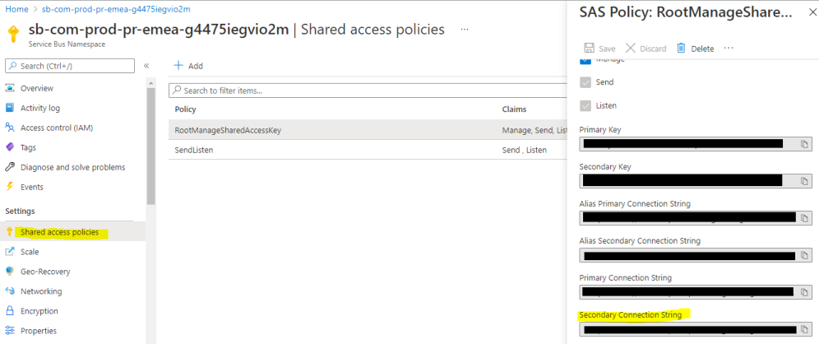

PART B: Connection with Service Bus Explorer

* Login into the VM open Service Bus Explorer

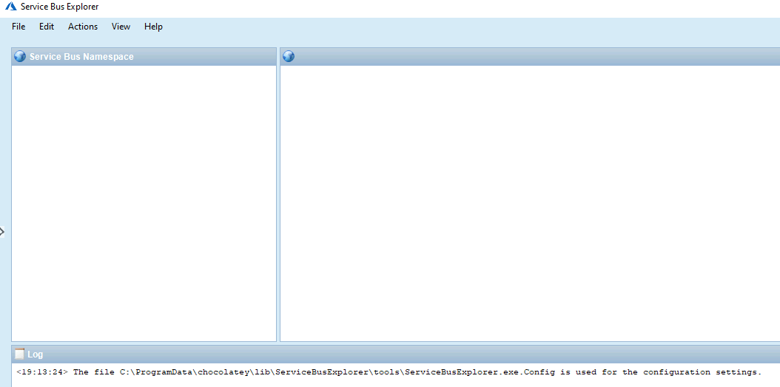

* To connect Click on File (Top Left Hand) -> ‘Connect’

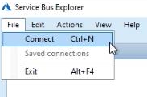

* Select Enter connection String from the Service bus Namespaces as shown below.

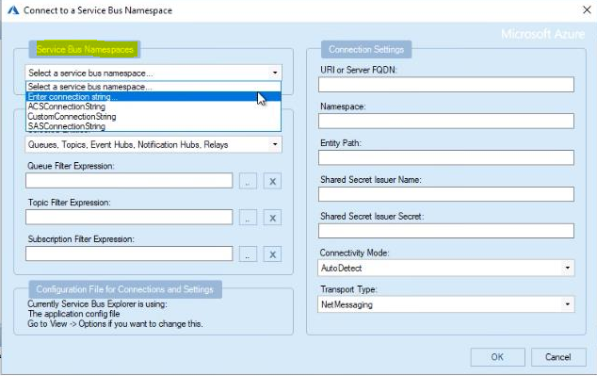

* Paste the **Secondary Connection String** mentioned in Part A in the Connection string box.
* **NOTE** : Connection String will be in the format of Endpoint=sb://resourse name

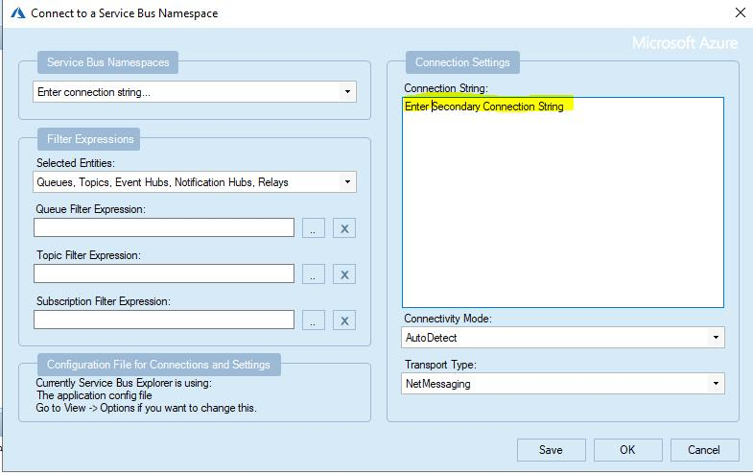

* Click on ‘OK’’.

After connecting to Service Bus. You will be able to see queue and topics as shown below

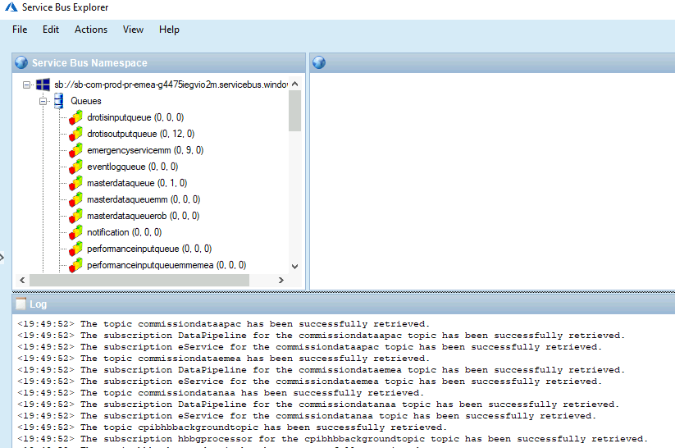

PART C: Deletion of Dead Letters

* Select the queue that has high number of dead letters.
* In right pane you will see the details regarding the queue selected.
* **NOTE** : Never attempt Delete option that can cause the deletion of the queue instead of Dead Letter Messages.

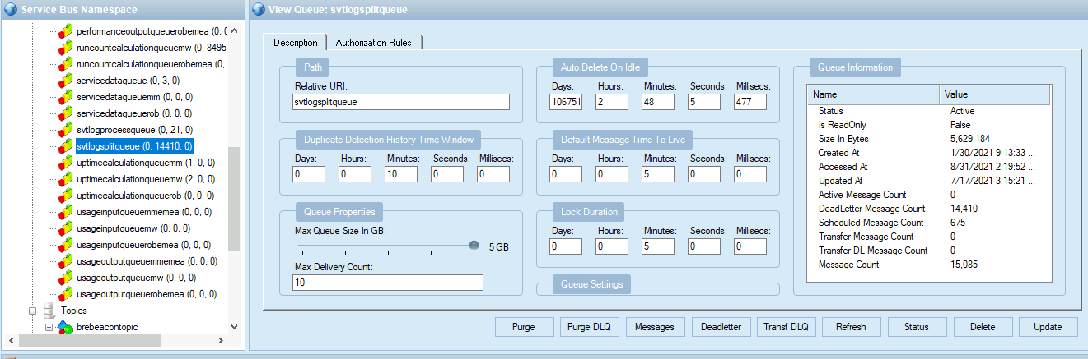

* **NOTE** : Before deleting the DeadLetter messages Kindly confirm it with Application Team.
* Right click on the queue and select **Purge Deleteletter Queue Messages** to delete the high number of dead letter messages.

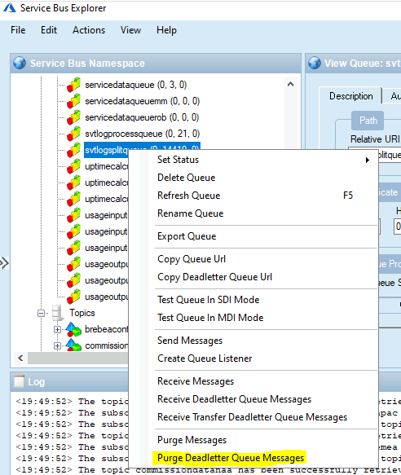

* After the deletion. Kindly check the metrics of **Count of dead-lettered Avg** in the Service Bus.

